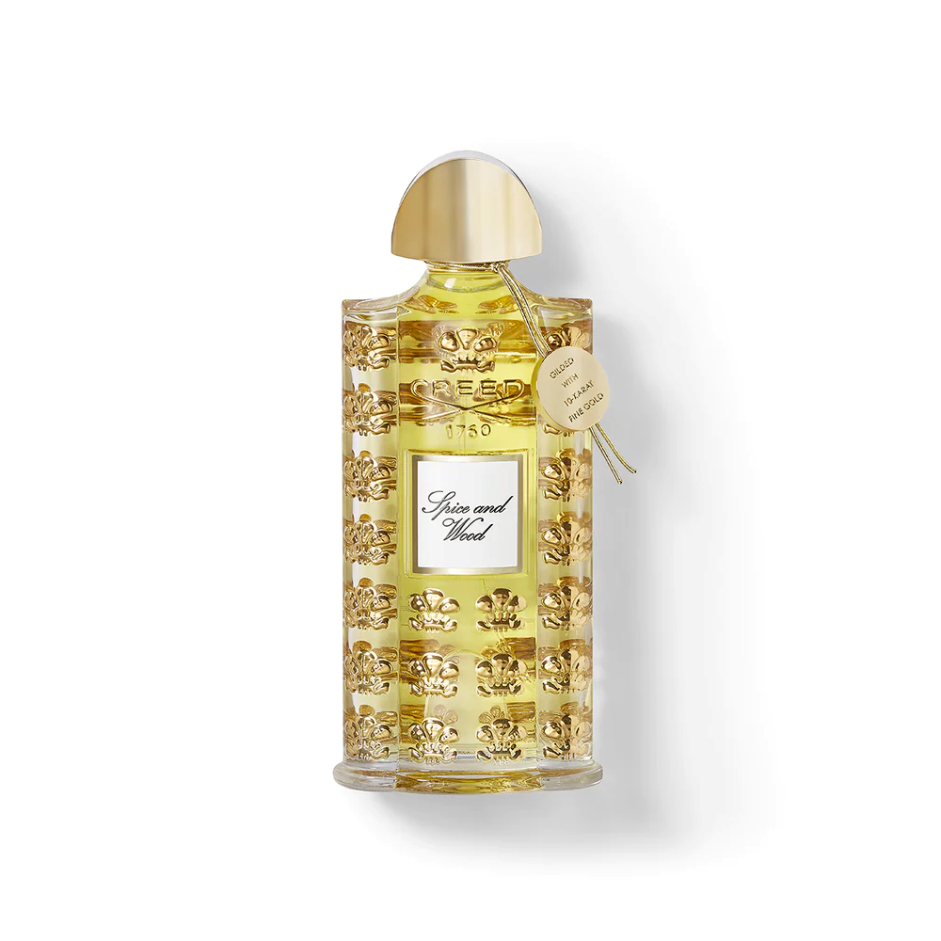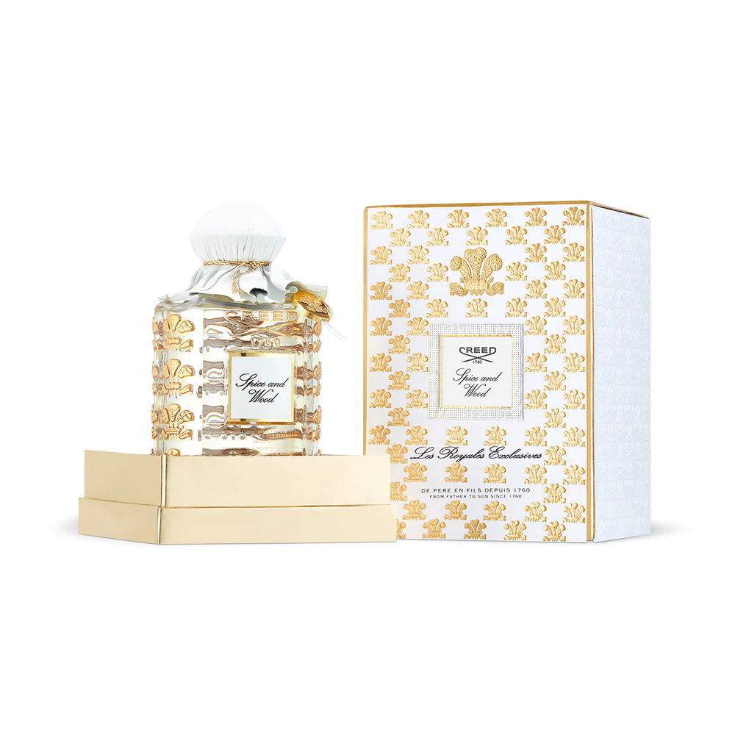

**CREED PURE WHITE COLOGNE**

**$610.00**

Tax Included.

Spray 100 mL

IN STOCK

### Product Details

Pure White Cologne evokes men’s styles in Victorian England; clean grooming and tailored clothes—like a jacket stitched to superb proportions.

Often compared to a burst of English mist, this citrusy blend gives way to subtle sweetness and powdery elegance, calling to mind the fine mist of a foggy London day.